Shankarenfo Pannagiani Dharma, Gurpreet Kaur, Neha, John-Vianney Ugonobo

Douglas college csis 4280  Course Group 4 Project

Tug-of-logic game project

**Abstract**:

A Tug-of-Logic game is a subjective game of debate, wherein debators must pick a side on selected CLAIM: For or Against. Debators then make STATEMENTS supporting their position or detracting the opposition. Each STATEMENT is argued/discussed upon in a single timed BOUT, which debators must live-vote on its truth value (TRUE/FALSE). The Judge can end this bout prematurely at any time. Once all statements have finished their BOUTS, a final vote is made on the CLAIM. After this, debators that have switched sides must now state their reasoning.

**Game: Tug of Logic**

-Multiplayer Game

-Players: 1 Judge (Instructor) & many Debators (Students)

**Features/Rationale**:

As a Judge:

* HOST a game by making a CLAIM.
* observe BOUTS
  + end them prematurely
  + ask questions during discussions
* reword the statements to fit discussion

As a Debator:

* Pick initial sides on CLAIM (For/Against)
* Create STATEMENTS regarding CLAIM.
* During BOUTS, discuss/debate regarding a CLAIM's truth.
* vote on a STATEMENT's legitimacy
* switch sides between BOUTS
* vote on CLAIM's legitimacy at final round
* cite their reasoning during closing

**Program Flow**:

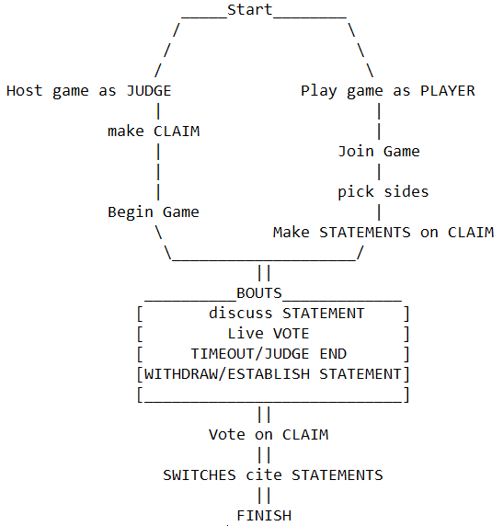

**Database Structure**:

**Flow of Interface**:

* Splash screen is displayed for 2 sec when the app starts. Then user is directed to Main activity.

* On main page three buttons are there- Host, Join and Exit. When user clicks on Host button user is taken to login activity. On click of Join button user is taken to Wait activity. When exit button is clicked it asks user whether to exit game or not.

* Host can login by using username, make an invitation to other players to play game or can make a claim.

* After login host is taken to Game activity where host can see number of players waiting to join the game. Here host can add, remove player from waitlist, can make claim.

* **Initial Tally View:** The main claim is displayed to the­­ players and they are given a chance to either support or go against the main claim. While they pick sides a live view of the number of players for / against is displayed alongside. The facilitator on the other hand gets to view all players and the sides they pick. They also get to edit the claim and end game whenever the like.

Initial Tally – Facilitator View

Initial Tally – Player View

* **Reason-in-Play:**  Next players are required to put forward a statement / RiP defending their choice towards the main claim. The facilitator view all statements and decide which is viewed in the next Bout session. They can also end the game at any point.

All RiPs – Facilitator View

Reason-in-Play – Player View

* **Bout View:** Here is a timed session where each player’s Reason-in-Play (RiP) is either agreed or disagreed with. A live voting view showing the number of players agreeing / disagreeing with RiP is displayed. We are looking to include a chat room where players can drop comments on the current RiP. Player can decide to change choice of main claim (i.e. for / against). The “Edit RiP” button would only appear for players. Facilitator monitors the activities of the players; they set the timer for each bout session and can begin or end each bout at any point in time.

**Bout – Facilitator View**

**Bout – Player View**

* **Final Tally:** After running through all the Reason-in-Play put forward by each the player get a final opportunity to switch or stick to choice. If a player decides to switch choice the any to include a reason for switch.

Reason for switch – Player View

Final Tally – Player View